

**Senior Design Project**

**Design of Adaptive Motor Controller with Built in Microcontroller and I2C Control**

ENGE476 Senior Design Project I

Department of Engineering and Aviation Sciences

University of Maryland, Eastern Shore

Justin Derickson

Project Advisor, Dr. Lei Zhang

Submitted

Mon. Day, Year

Special notice for formatting:

1. Don’t add any blank rows. Use spacing or page breaks.
2. Every figure or picture inserted in the text, must be accompanied with the caption and detailed description.
3. Keep the formatting consistent (learn and apply the MS ‘Styles’ in formatting).
4. The final report didn’t meet the basic formatting requirements won’t be accepted.

List of Contents

Special notice for formatting: 2

1. Don’t add any blank rows. Use spacing or page breaks. 2

2. Every figure or picture inserted in the text, must be accompanied with the caption and detailed description. 2

3. Keep the formatting consistent (learn and apply the MS ‘Styles’ in formatting). 2

4. The final report didn’t meet the basic formatting requirements won’t be accepted. 2

Table of Contents 3

Abstract 4

1. Introduction 4

1.1 Backgound/Motivation 4

1.2 Objective 4

1.3 Design Requirements 4

1.4 Design Constraints 4

1.5 Design Methods 4

2. Project Description 4

2.1 System Description 4

2.2 System Diagram 4

2.3 System Functions 4

3. Implementation Plan 4

3.1 Tasks 4

3.2 Team Organization 4

3.2.1 Responsibility of Team Member 1. 4

3.2.2 Responsibility of Team Member 2. 4

3.3 Timeline/Milestones/Delivery Plan 4

4. Implementation 4

4.1 Implementation of Task 1. 4

4.2 Implementation of Task 1. 4

5. Conclusion. 4

Acknowledgement 4

Appendix 4

A. Component Specs 4

1. Specs of Arduino Due 4

2. Specs of Raspberry Pi 4

B. Source Code. 4

1. Source Code of Graphic User Interface 4

2. Source Code of Robotic Arm 4

REFERENCES 4

List of Figures

List of Tables

Table 1. Project Timeline and Delivery Plan 13

Abstract

By the end of the project, summarize the project into short text and put here.

1. Introduction

## Backgound/Motivation

It seems that in lower level robotic projects, it is fairly commonplace for the electrical components to become an afterthought. When such projects progress, power and control requirements become more demanding and complex. Microcontrollers, single board computers, motor controllers and regulator circuits will be added as needed. Very often, appropriate planning for organization and layout is done and the resulting cacophony of wire and boards becomes hard to follow and impossible to troubleshoot.

A few semesters ago I was asked by a colleague to assist with a project. He was working with a professor who was developing an autonomous aquatic water sampling platform for the USDA. He informed me that they were having difficulty troubleshoot an electrical problem and I knew that this would exactly be the case.

The platform was a boat that used a winch, a turntable, a pump, multiple servos, and valves. All of which were being driven by their own separate control circuitry that each took up a good deal of space in the already large enclosure. There were 3 Arduino microcontrollers, a Pixhawk flight controller, 4 motor controllers, and an 18-relay switching board. Everything was connected through a breadboard that after previous troubleshooting attempts was arranged haphazardly with loose unorganized wires. The documentation was no longer up to date after multiple attempts at troubleshooting so the only option was to disassemble everything and rebuild and document everything from scratch.

Another issue I found was that because none of the control system was purpose built, there was an enormous amount of redundancy in each component, arbitrarily increasing the cost and power consumption of the system. I ended up working on the project and have managed to eliminate most of these issues but the lack of organization ended up resulting in a lot of extra work.

This is a fairly regular occurrence. I have had multiple personal projects turn out this way and it is an issue with many of the other ongoing projects at the school. In order to avoid problems like this where purpose made control circuits aren’t available, planning and forethought is needed to avoid complications.

## Objective

The objective of this project is to develop a standalone system that will address power distribution, motor and servo control, and general input and output on a single board. This would effectively negate the issues seen in projects where these things are all implemented separately.

## Design Requirements

While not a specific requirement, all design decisions made in this project should be made so that the final product is as small and inexpensive as possible. For ease of explanation, the requirements can be split into three categories. They are as follows:

1. Output Requirements: Electromechanical Control Specifications
   1. The device should provide control for either a single bipolar stepper motor or up to two DC motors, which need to be controlled independently.
   2. The device should be able to drive either type of motor with an operating voltage between 5 V and 24 V at a current up to 1.5 A per motor winding.
   3. The device should possess general input and output (GPIO) for feedback from motors with a built-in quadrature encoder.
   4. A high resolution PWM output compatible with the operation of a typical servo motor.
   5. The device should have on board power for 5 servos with a stall current of 1 A
   6. The motor and servo power supplies should be configurable from the microcontroller firmware.
2. Power and Control Requirements
   1. The device will likely be powered by a battery, so it should operate on a voltage between 9 V and 24 V.
   2. PWM input from a typical RC receiver should allow for basic functions like throttle steering and sampling.
   3. Full functionality should be accessible through I2C control.
   4. A stable 5 V supply for powering external devices should be available.
3. Firmware Requirements
   1. There should be a set of functions that define motor type and the voltage that it operates at.
   2. Any of the PWM pins should be configurable as a servo
   3. The motor and servo voltages should be configurable separately to any value within the specified range.
   4. For every motor and servo, there should be a function to rotate incrementally, move to a desired position, set the value of the current position, and to return the current position.
   5. GPIO and PWM pins should be configurable as input, output, quadrature encoder, or servo.
   6. There should be functions that read and change the state of GPIO and PWM

## Design Constraints

The only constraint of this project is the budget.

## Design Methods

After establishing a general system description, the circuit needs to be designed. This will require selecting components that meet the project requirements, reading the manufacturers documentation and design considerations and performing all of the calculations and simulations necessary to verify system functionality.

After finalizing the circuit design with prototypes, the circuit board must be designed. This will require first finding a manufacturer and consulting their circuit layout requirements. Many small batch circuit board manufacturers have requirements on things like hole diameter, tracewitch and board size. This is usually done to keep costs down during manufacturing by avoiding tool changes and other major alterations to the fabrication process.

After consulting the manufacturer’s design limitations, the board layout will be done using a specialized CAD software and will be sent to the manufacturer for verification. They will often send design recommendations specific to their manufacturing process. After taking these into consideration the finalized board sent off to be manufactured and shipped within a few weeks.

During the shipping process the algorithm design and firmware coding should be started and verified using functional prototypes. After the PCB is delivered and populated, the firmware should be loaded onto the microcontroller and a full functional verification should be performed

1. Project Description

In this section you are going to add more details of 'what' and answer the question 'how'.

## System Description

The system description is different to objectives. The description is more from inside, talks about what is inside the system. For example: "The vehicle is controlled by the microprocessor Arduino, driven by the battery, navigated by …"

## System Diagram

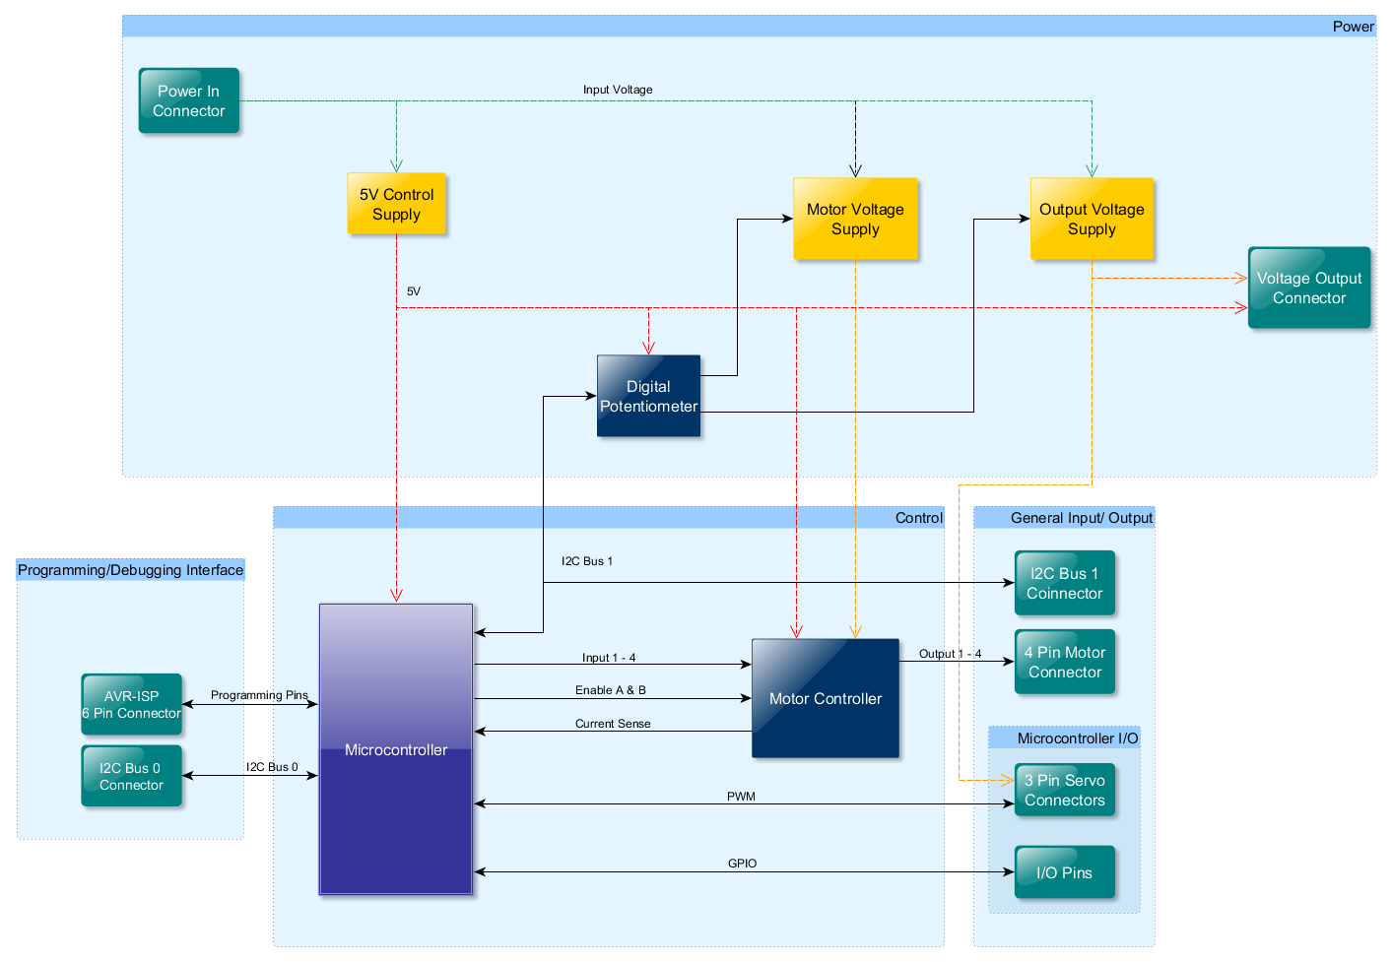

1. System Diagram: (a) main system, (b) subsystem1, and (c) subsystem2.

## System Functions

### Control

The control section is responsible consists of two main components; The microcontroller and the motor controller. The microcontroller is the central component of the system and responsible for control of the power supplies and motor controller that allows for control of a single bipolar stepper motor or two regular DC motors. Their functionality is described below.

#### Microcontroller

The embedded microcontroller will be responsible for driving the motor controller and interfacing with attached devices. This is done through the I2C communication standard and general input and output that supports PWM, Interrupts, and Analog to Digital conversion.

#### Motor Driver

The embedded motor controller receives stepping logic and current control from the microcontroller. Current control is achieved by applying a Pulse-Width Modulated signal to the enable pins. As the duty cycle of the PWM varies, the current through the motor windings varies linearly. Feedback to the microcontroller is provided by two 0.5 Ω resistors attached to the sense pins on the motor controller and two ADC pins on the microcontroller.

#### Digital Potentiometer

### Power

The power section is responsible for supplying for supplying power to the system. Due to the noisy nature of motor driving circuits and the open-ended application for which this device is intended, power outputs must be well filtered to avoid instability. This section consists of three linear voltage regulators and an I2C controlled linear potentiometer with two outputs. One regulator provides a clean 5V line and the other two are controlled by the digital potentiometer.

#### 5V Supply

A standard 5V linear voltage regulator provides a filtered 5V line for the power the microcontroller, motor controller, digital potentiometer, and USB to UART converter.

#### High Current Variable Supplies

A high current linear voltage regulator that provides the motor power to the motor controller. This output will depend on the motor being used and is set by the microcontroller.

1. Implementation Plan

## Tasks

* Task 1. Schematic Layout
  + Subtask 1.1 Control Section
  + Subtask 1.2 Power Section
* Task 2. Verification
  + Subtask 2.1 Breadboard Equivalent Circuits
  + Subtask 2.2 Write test code
  + Subtask 2.3 Testing and Measurement
* Task 3. PCB Design
  + Subtask 3.1 Manufacturer Selection
  + Subtask 3.2 Part Placement
  + Subtask 3.3 Design Rule Confirmation
* Task 4 Firmware Coding
  + Subtask 4.1 Write Code
  + Subtask 4.2 Test with circuit prototypes
* Task 5 Final Assembly and Testing

## Team Organization

I am the only one working on this design project, therefore I will be taking on all project responsibilities.

## Timeline/Milestones/Delivery Plan

Please prospect the timeline to deliver the results of each task/subtask.

Please schedule your project to no more than 22 weeks from now.

1. Project Timeline and Delivery Plan

|  |  |  |  |
| --- | --- | --- | --- |
| **Time** | **Task** | **Comments** | **Responsible Personnel** |
| Week 1 | Start Subtask 1.2 | Caller display coding. Three weeks needed. | Albert Einstein |
| Week 3 | Finish Subtask 2.2 | Delivery of the CAD file of the vehicle frame design. | Isaac Newton |
| … |  |  |  |
| Week 22 | Finish task 4.6, 9.10, … | System finalization and delivery. Finish all documentations and ready for presentation. | … |

1. Implementation

## Implementation of Task 1: Schematic Layout

### Control Section

Lorum Ipsum…

#### Motor Controller

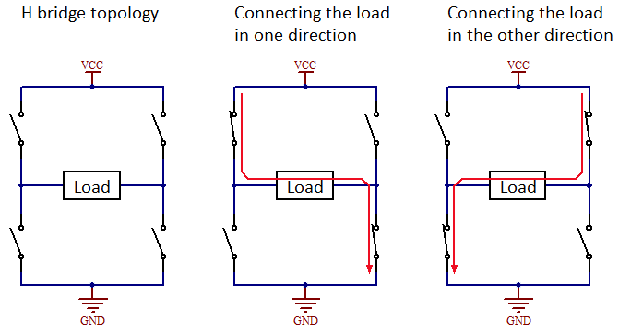The primary component of this system is the motor driver. It needs to drive a single bipolar stepper motor or two brushed DC motors. This requirement eliminated a lot of more complex options in order to have a fully controllable output. Because of this, a simpler dual H-Bridge is the best option.

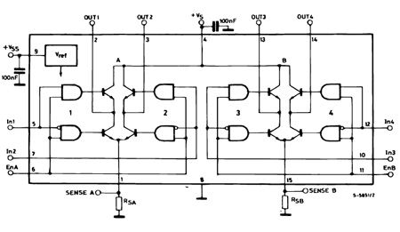An H-Bridge is an arrangement of transistors that allows for the direction of the current in a load to be changed. In the circuit, the transistors are set up so that they function as a switch like in the figure to the left. By changing which transistors are turned on, the path the current takes to ground changes. By employing two of these, the current going through the windings can be controlled.

After some research, I found that the L298N motor controller is a common, dual H-Bridge IC with Independent enable pins and current sensing capability that meets the current and voltage requirements.

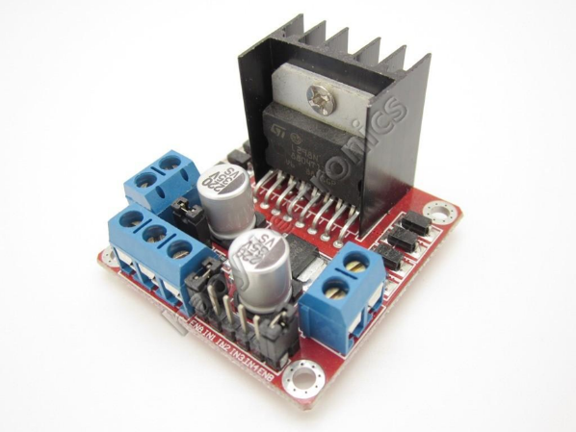By providing a PWM signal to the enable pins, the current going through the motor winding can be controlled with feedback from the current sense pins. In the case of driving two motors, this allow the speed of the motors to be controlled individually. In the case of a bipolar stepper motor, the current going through the windings determines the torque of the stepper motor.

The circuit layout for the L298N is fairly simple. For current sensing, a 0.5Ω resistor connects each current sensing pin. The voltage across these resistors is proportional to the current going through the attached load. There are also two snubber diodes connecting each outputs to the motor supply voltage and circuit ground to safely protect the outputs from back emf produced by the motors.

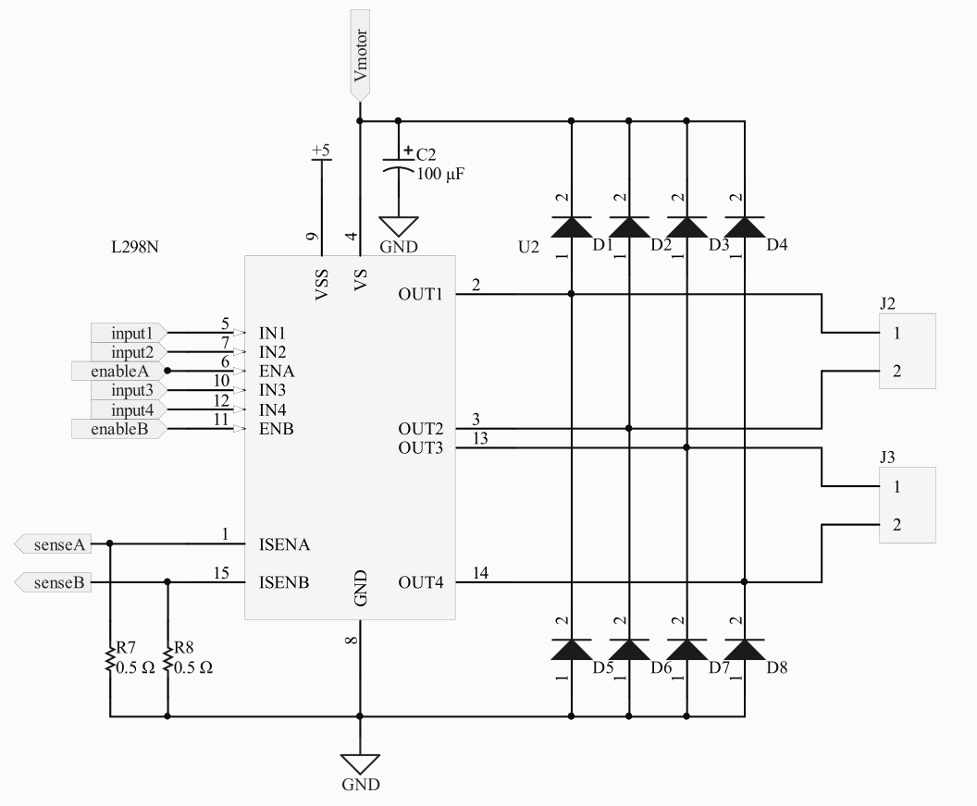

#### Microcontroller

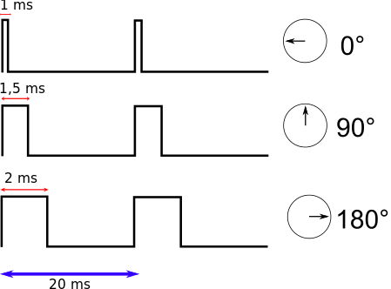 One of the most important features of this board is to read and write Pulse Width Modulated (PWM) signals. PWM is a type of modulation encodes information into the width of a pulse that occurs at an application specific frequency. The ratio of on time to off time is referred to as Duty Cycle. By varying the duty cycle of a PWM signal one can perform tasks such as dimming an LED or driving a speaker. In the case of this device, it will be used to control the torque of the motor attached to the motor controller.

PWM is not only required for the motor control circuit, but is also used as a control method in many electromechanical devices such as servos and linear actuators. These devices are typically found in remote control applications and drones, so PWM channels are often used for control in autonomous flight controllers, like the PixHawk and ArduPilot, as well as handheld RC transmitters. The focus of this project is to integrate primarily with these types of devices.

1. Servo PWM control.

We also need the ability to communicate via I2C. I2C is a short-distance communication standard developed by Philips Semiconductor (now NXP Semiconductors) in 1982. Since then it has become a word standard and can be found devices like display drivers, remote I/O ports, sensing devices, etc. In fact, the initial design for this system called for a 16 channel PWM expander controlled with I2C.

I2C is convenient in that it only two bus lines are required; a serial data line (SDA) and a serial clock line (SCL). According to the I2C standard, each device on the bus is software addressable using a unique address and simple Master/Slave relationships exist between the main device and peripheral devices at all times. Other communication protocols, like SPI, require a chip select pin for each attached device in order to enable communication. The obvious drawback being that the number of interfaceable devices is limited to the number of free pins on the microcontroller. The number of devices on an I2C bus is limited by the capacitance of the bus.

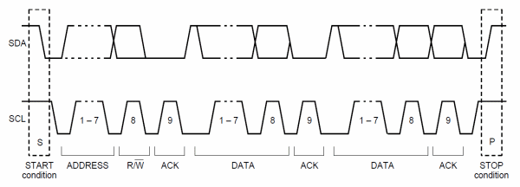

Illustration of typical I2C communication.

I2C communication can seem complicated at first, but it is fairly straightforward. First, the master device leaves SCL high and sets SDA low. This tells all devices on the bus that communication is about to start. After setting the start condition, the master device transmits the address frame. It sends the 7-bit address of the device that it is trying to communicate with one bit at a time. Followed by an R/W bit specifying whether it is a read (1) or write (0) operation.

The 9th bit of every frame is the acknowledge (ACK) bit. After the first 8 bits are sent, the receiving device is given control over the bus and is given the opportunity to pull the SDA line low. This indicates to the master device that the last frame was received. If the SDA line is not pulled low, communication halts and the master device proceed however instructed.

After the address frame is sent, the master device begins generating clock pulses at regular intervals. Depending on the R/W bit, either the master or slave device will start sending data 8 bits at a time with an ACK bit in between each.

When all data frames have been transmitted, the master device first sets SCL high, then SDA. This is the stop condition. During normal data transfer, the state of SDA should never change when SCL is high in order to stop false stop conditions.

After extensive research, the ATmega328PB microcontroller from the AVR series of microcontrollers developed by Atmel was selected for this application. The more ubiquitous ATmega328P is the microcontroller is found in the extremely common Arduino Uno microcontroller board. The PB variant of the ATmega328 is a newer version of the one found in the Arduino Uno with some marked improvements. It has two 2-Wire interfaces (compatible with Phillips I2C), 2 Serial UART’s, 2 SPI interfaces, a 10-bit ADC, and 10 PWM channels. This is a marked improvement on the Atmega328P.

The first task of the microcontroller circuit layout was to decide which pins would control the L298N motor controller. 6 pins are required to properly drive it. Four general I/O pins are needed for the L298N INPUT pins. Two ADC pins are needed for the SENSE pins in order to take advantage of the L298N’s current sensing capabilities.

The ENABLE pins on the L298N can be driven with either one or two PWM pins depending on the application. When driving a bipolar stepper motor, only one PWM is needed if implementing full or half stepping. Two PWM’s are needed if implementing microstepping. When driving two standard DC motors, the separate ENABLE pins can be driven with the same PWM if they need to be run at the same speed. Otherwise, both are needed.

In order to take advantage of this flexibility, I added multiple 0 Ω resistors in a configuration that allows the second PWM pin to be connected to an external pin or to an ENABLE pin on the L298N.

According to the AVR® Microcontroller Hardware Design Considerations application note, the SPI lines (SCK, MISO, and MOSI pins) should have series resistors in place to prevent devices connected to those pins from driving the lines and damaging the programmer/debugger. To make these resistors unnecessary, they are being used to control the L298N input pins. AVR® microcontroller do not drive these lines when in programming mode and the input pins of the L298N do not supply any current, so there is no concern of damage to the programmer/debugger.

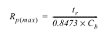 According to the I2C standard, there should be a pull-up resistor on the SDA and SCL lines. The maximum value of these resistors is dependent on rise time (tr) and line capacitance (Cb). The minimum value of these resistors is dependent on the supply voltage (VDD) and the sink current (IOL).

1. Rp(max)

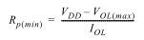 After estimating the maximum bus capacitance to be around 100μF, and assuming a 3mA sink current for standard I2C operation, the minimum and maximum values of the pullup resistors are 1.6kΩ to 40kΩ. I selected a value of 10kΩ. This is a resistor value common to other parts of the system, which will make ordering parts easier.

1. Rp(min)

The RESET pin requires a pullup resistor to keep the device from accidentally resetting and to debounce the external reset button. Since the RESET pin is also used in programming and debugging. A pullup resistor is required on the reset pin to keep it from accidentally going low and resetting the device, a value of at least 10kΩ is necessary for reliable programming and debugging. 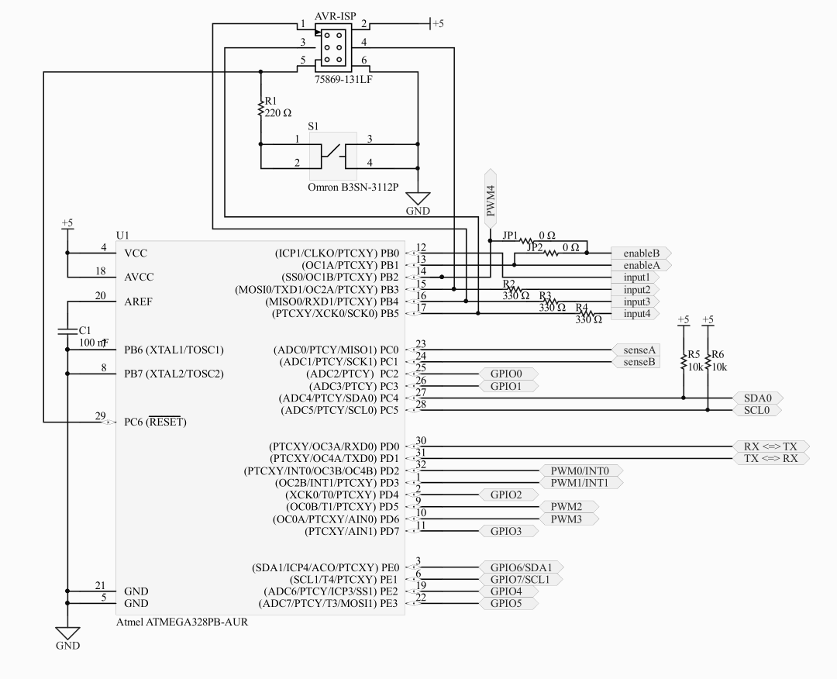

#### Digital Potentiometer

The control portion of the power supply system is an I2C controlled digital Potentiometer that will vary the resistance of the bottom resistor in the voltage divider circuit that sets the output voltage of the linear regulator.

The AD52** series of digital potentiometers are dual output, I2C controlled chips with a 256-bit resolution. The AD5248 has 2 pins that allow for a configurable I2C address. Setting the address is done by setting the two pins either high or low. This is accomplished by two 0Ω resistors setting the pins high or low. The outputs of the digital pot are equivalent to the wiper and end terminal of a traditional analog pot.

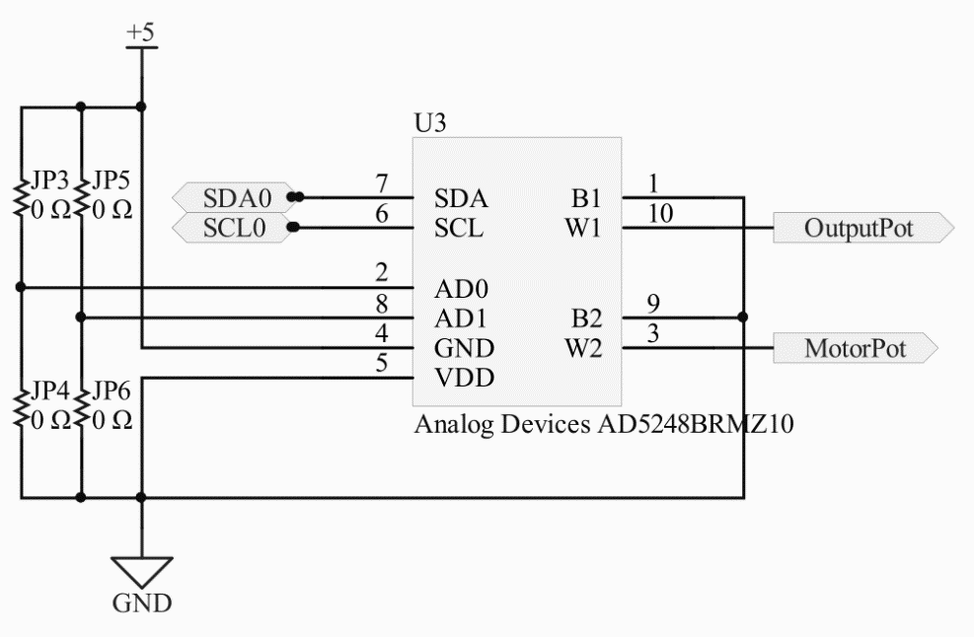

### Power Section

Lorum Ipsum…

#### 5V Linear Regulator

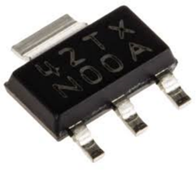The power system of the board requires 3 main components. The microcontroller, motor controller, digital pot, and programmer all require a 5V source. A standard 5v linear regulator effectively fills this role. The LM340P is a small form, surface mount equivalent to the ubiquitous LM805 linear voltage regulator and is electrically implemented in the same way, with filter capacitors on the output for stability and the middle pin connected to ground. The output is connected to the digital power pins on each device on the board and is kept separate from the noisier, higher power sources used for the motor and general output.

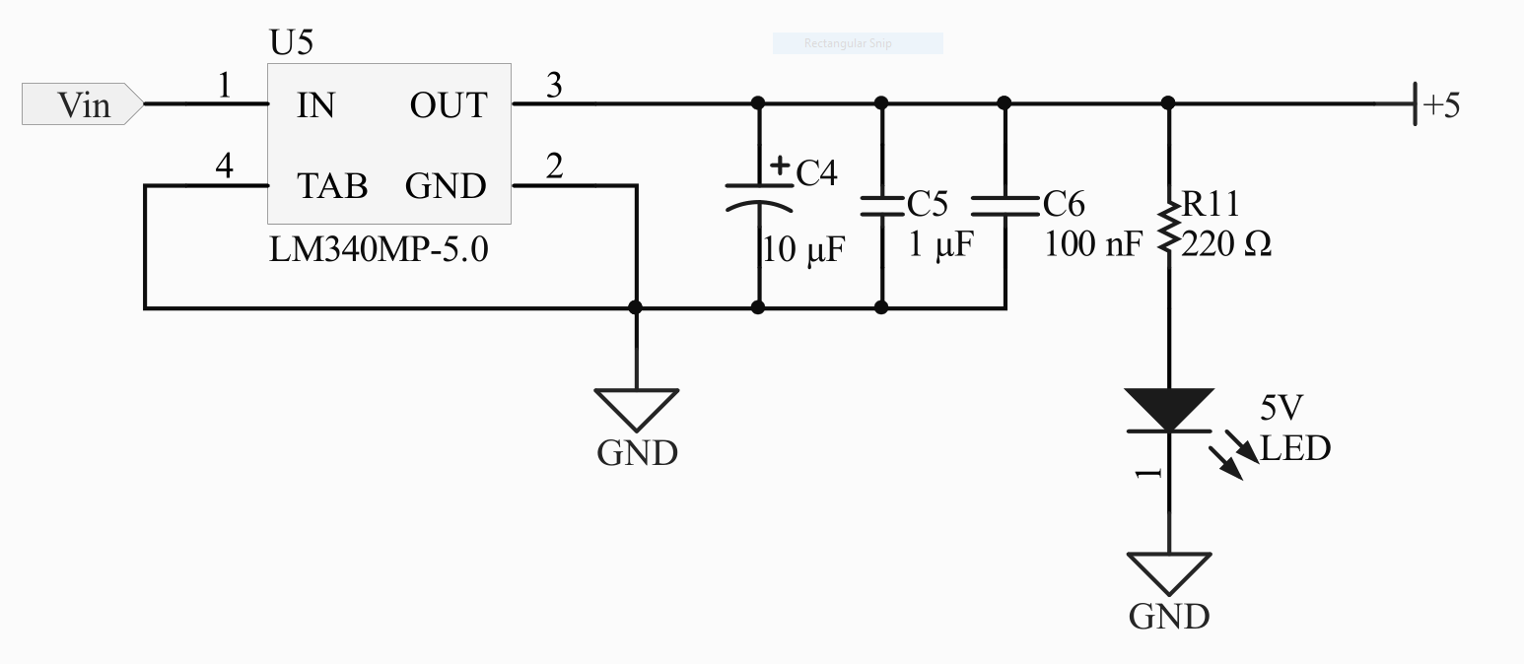

#### Adjustable 5 Amp Regulators

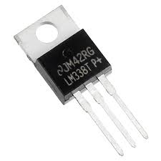 The main component of the motor and output power supplies is an LM338 adjustable voltage regulator. Functionally equivalent to the popular LM317, the LM338 has a higher input voltage range and output current. Diodes are connected across the input and output of the device and in parallel with the digital pot resistance to protect the low impedance output from damage when the larger valued capacitors on the output of the circuit discharge. A capacitor placed in parallel to the digital pot resistance helps improve the circuits transient response and the capacitors on the output help remove noise and keep the output voltage stable. It is likely that this part of the system will be subject to noise because these circuits will be used to power electromechanical devices. So it is important that appropriate filtering is implemented.

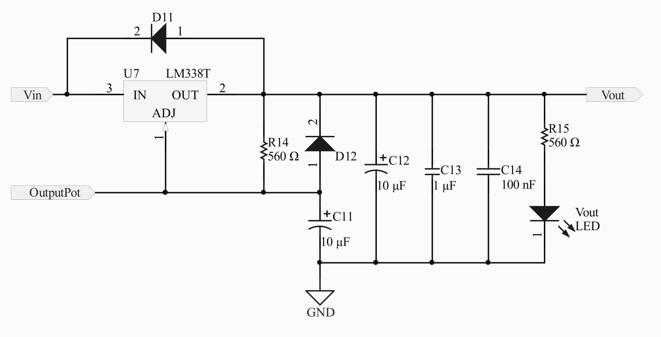

## Implementation of Task 2: Circuit Verification

Lorum Ipsum…

### Breadboard Equivalent Circuits

Before manufacturing, testing and functional verification needs to take place. For this phase of design, an analog for each section of the system are used to test the connections between each section and basic test code needs to be written to verify proper control of each section of the circuit.

#### Power for Test Setup

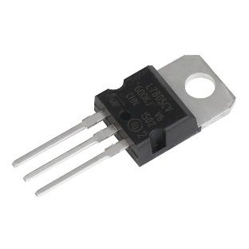Power to the microcontroller, motor controller, and digital potentiometer is provided by an LM7805 5V linear voltage regulator, which was used as an analog for the surface mount regulator chosen for the final design. Because circuit design remained the same and the electrical characteristics of both devices are similar, the LM7805 serves as an effective analog for the regulator in the final design.

#### ATmega328PB Test Setup

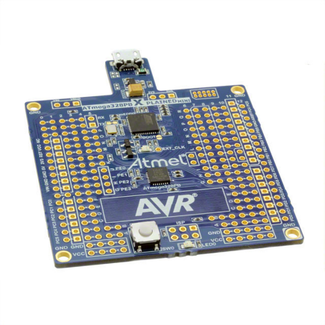For each AVR microcontroller, Microchip produces an inexpensive evaluation board. The ATmega328PB-XMINI is the evaluation board for the ATmega328PB. These boards come with a fully integrated debugger compatible with Atmel Studio, a popular and free IDE which is capable of debugging and limited chip simulation. It is also designed so that with the addition of header pins to the bottom of the board, it can be attached to an Arduino Uno or a breadboard for testing and simulation. The addition of the header pins is the only modification that needs to be made to the XMINI before it can be used in this application.

#### L298N Test Setup

Simulation of the motor control section a pre-made L298N motor driver board. Since the L298N is commonly used, breakout boards with a circuit that conforms to what is required in the datasheet are widely available and relatively inexpensive. Unfortunately, modifications need to be made to use it for this application. First, the power, input, and enable connectors needed to be removed and replaced with breadboard compatible header pins. Then, the sense pins needed to be cut from the board and soldered to a wire. This allows the current sensing feature of the L298N to be taken advantage of. Because the motor power section of the system will under test as well, the motor supply voltage for the L298N comes directly from the 12V powering the system. This way the motor driver will be isolated from other parts of the circuit and wont be affected by malfunctions in other parts of the system.The L298N was then connected to the ATmega328PB in the same way that it will be connected in the final design.

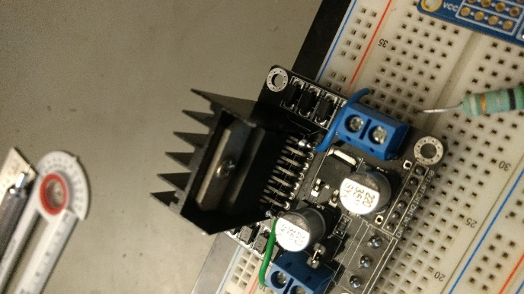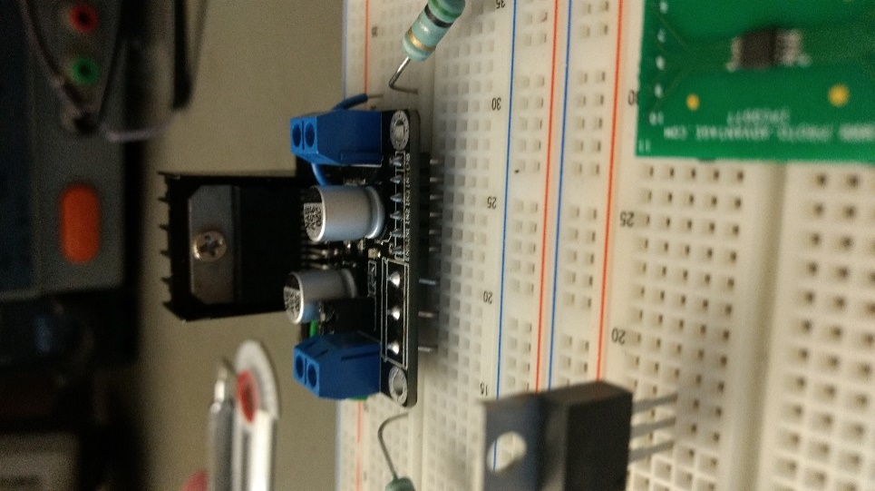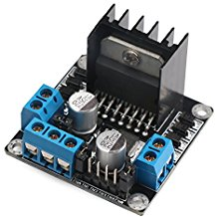

#### Digital Pot Test Setup

The power section of the system consists of two LM338 linear voltage regulators and a AD5248BRMZ10 digital potentiometer. The LM338’s in the test set up are connected as they should be in the final design using the equivalent through hole components. The digital potentiometer that controls them does not have a through-hole equivalent. This complication was dealt with using a msop-10 breakout board. The digital pot is connected to a board with the appropriate footprint on it and soldered in place. Then header pins are soldered to the underside of the board to allow it to be inserted into a breadboard. This proved to be the most challenging part of assembling the test setup due to the size of the component. Soldering it was difficult and required a few tries.

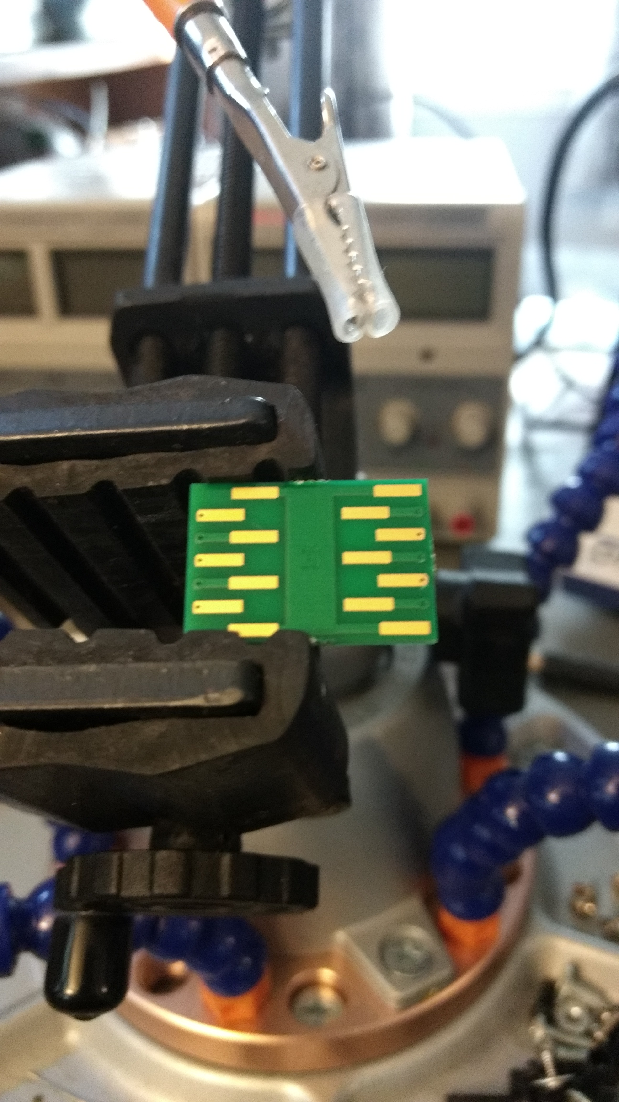

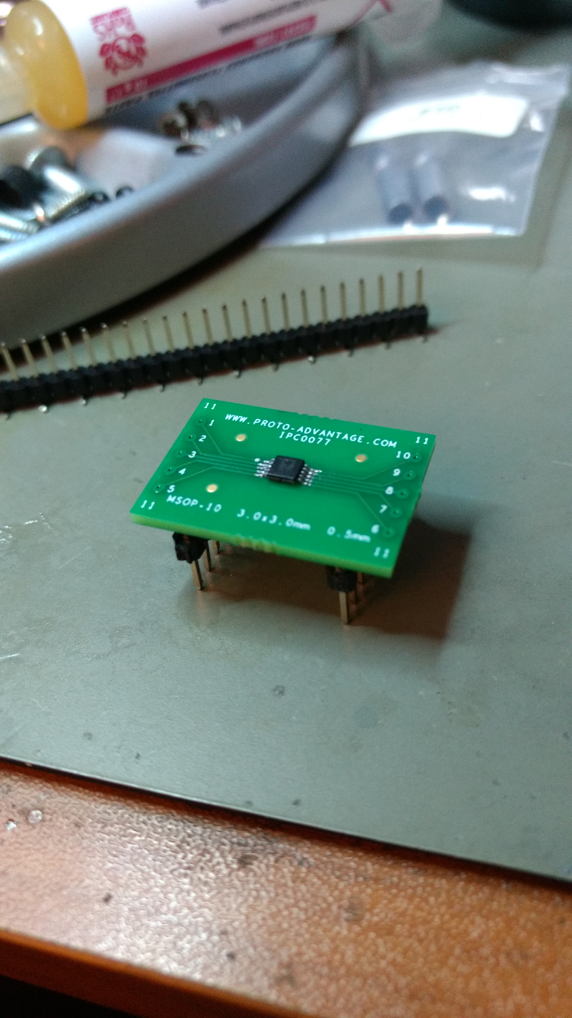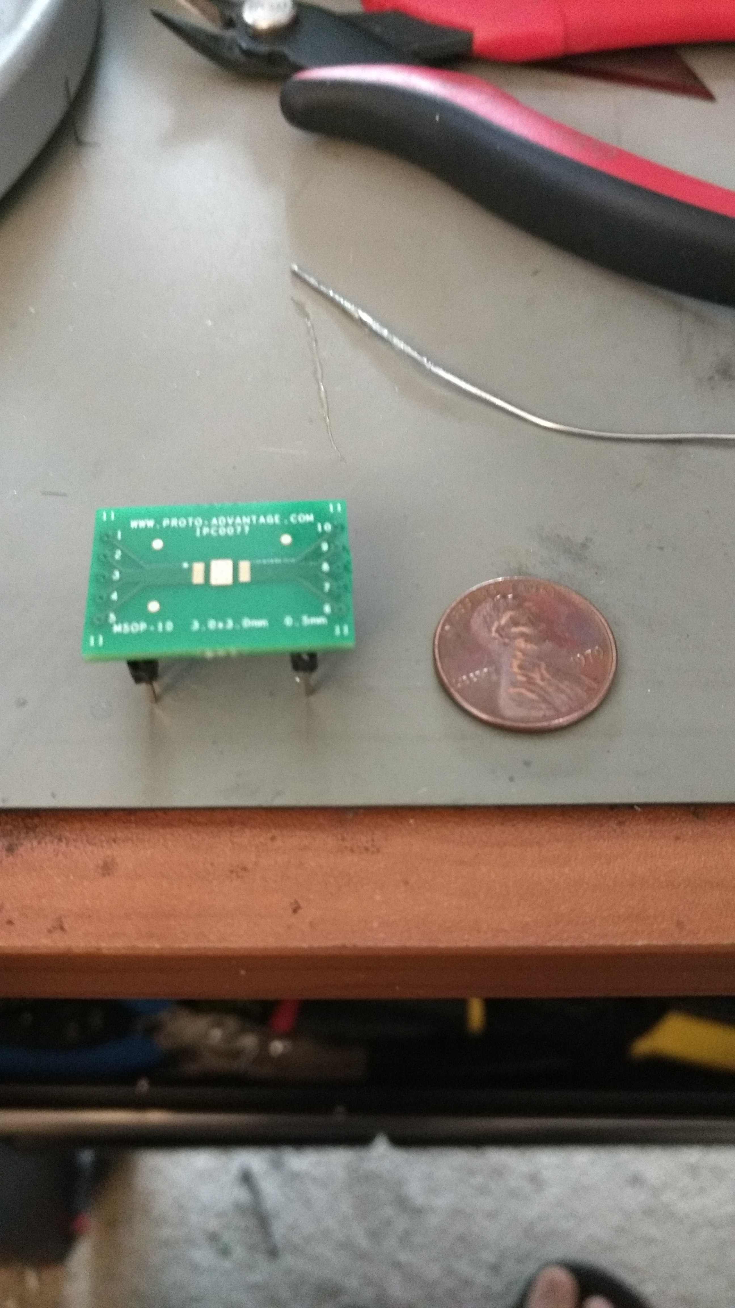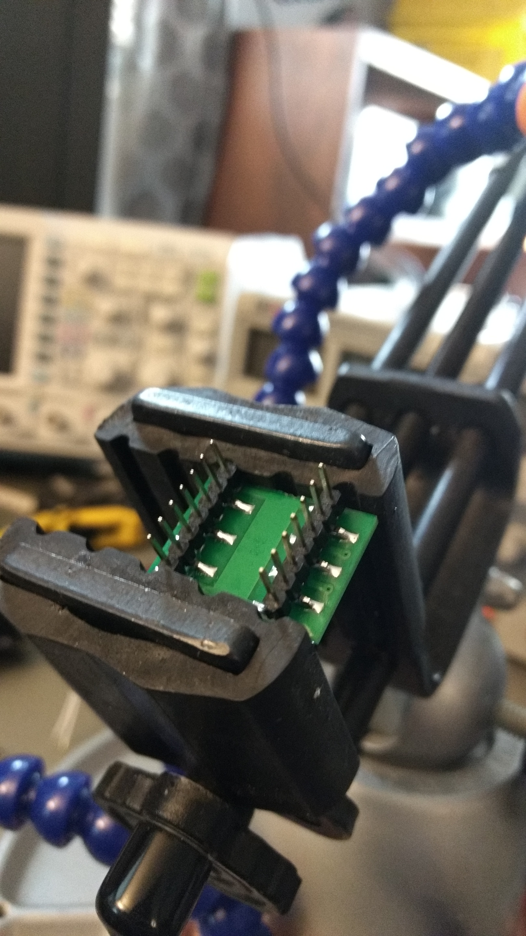

After all components were setup in a breadboard compatible configuration, they were attached to the board and wired according to the final product schematic.

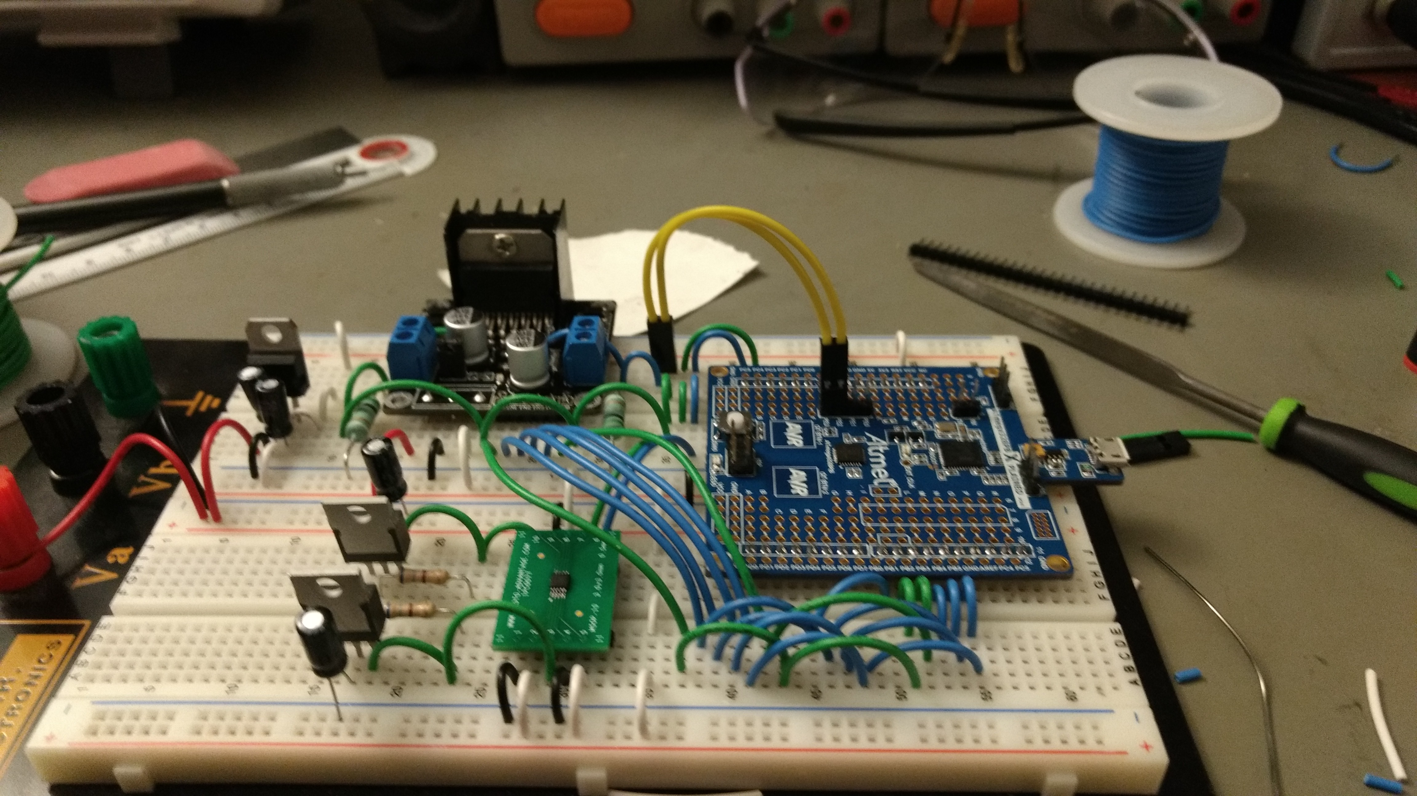

### Test Code

#### Motor Control

The L298N motor controller requires 6 inputs, four logic inputs and two enable inputs. The enable inputs typically have a PWM signal applied to them in order to control the amount of current going to the windings of the motor.

#### PWM in the ATmega328PB

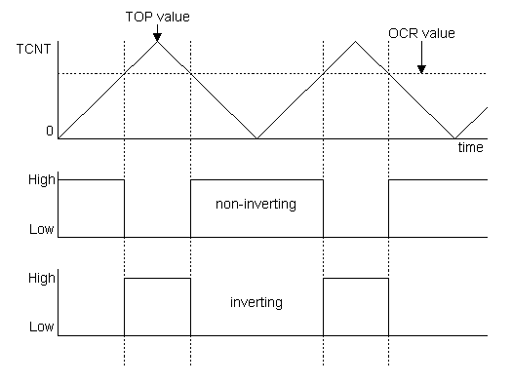The first step in achieving motor control is setting up the PWM for the enable pins. In order to generate a PWM on the ATmega328PB, the timer for the desired pin must configured for PWM output.

The PWM output from an AVR microcontroller is generated by comparing the value of an incrementing and decrementing counter with selected OCR value. When the counter value meets the OCR value, the state of the PWM changes. This generates the PWM output signal.

On the 328PB, there are 10 PWM channels on five separate Timer/Counters; with two PWM channels on each timer. On the datasheet, pins with the label OCnx are configurable for PWM output. The ‘n’ character is the associated timer and the ‘x’ is either PWM channel A or B on that timer. Since two PWM channels are being used, it is simpler for them be on the same timer.

The outputs selected to control the enable pins on the L298N are OC1A and OC1B. They are connected to pins PB1 and PB2. In order to generate a PWM pulse on a pin, it’s associated Timer Control Register (TCCRnx). There are three 8-bit TCCRnx registers for each timer, labeled A, B, and C. Setting the bits in the TCCR1x registers configures the PWM output signal. For the purposes of controlling the L298N, an 8-bit fast PWM is sufficient. This can be using the following snippet of code:

DDRB |= 0b00000110;

TCCR1A = 0b11110001;

TCCR1B = 0b00000010;

TCCR1C = 0b00000000;

The first line configures pins 1 and 2 of Port B as outputs. These are the pins that the PWM signals will be output from. The next three lines set the values of the bits in the Timer/Counter Control Register. Each bit controls separate settings that control the behavior of the counter.

By setting a value between 0 and 255 to OCR1A and OCR1B, the PWM output can be manipulated. The following figure shows the XMINI evaluation board and L298N under test with OCR1A set to a value of 128. This produces a PWM signal with a %50 duty cycle, visible on the screens of the oscilloscope and multimeter connected to PB1. The L298N outputs are only enabled for half of the time that the device is on, but is switching so fast the device effectively averages the enable input and cuts the motor voltage in half. This is known as “chopping” the input. Combining this with measurement of the current sensing resistors using an ADC input allows for active current control and shutoff of the attached motor.

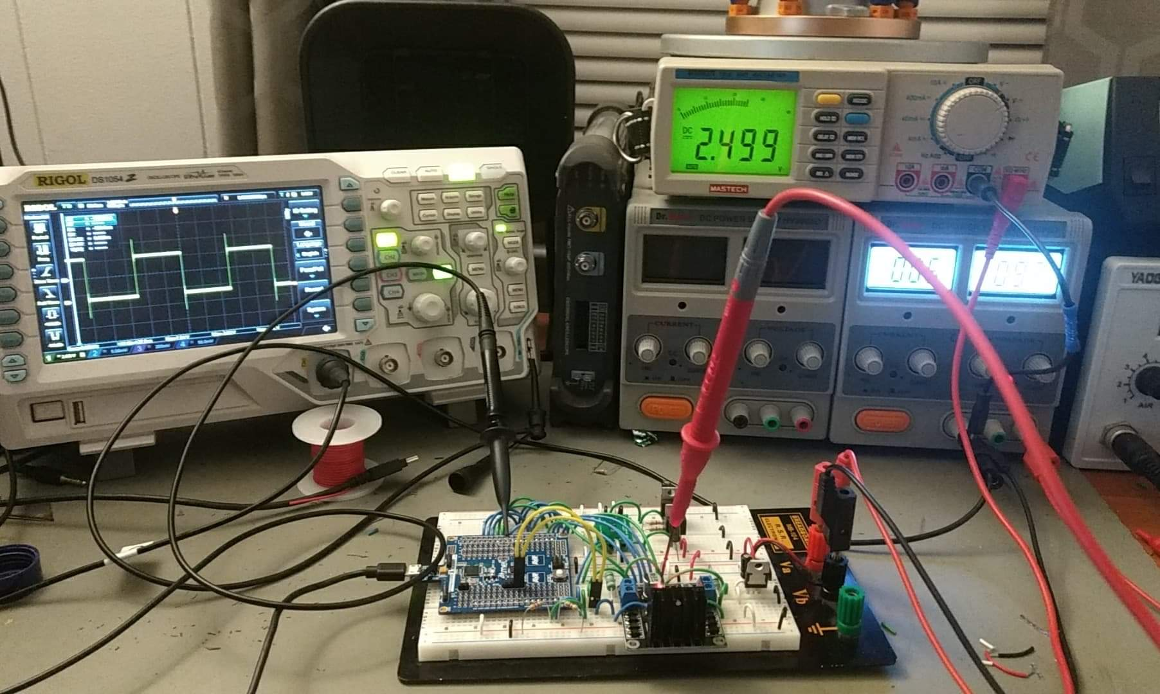

#### Single DC Motor Control

After setting up a PWM output to control the motor speed, controlling standard dc motors is the next step. Taking the schematic of the h-bridge circuit from the L298N datasheet, it can be inferred that the direction of the current flowing through the motor windings.

In the case of a single motor connected to output 1 and 2 of the L298N, the direction of rotation of the motor is controlled by the state of inputs 1 and 2. A high state on one and a low state on the other controls the clockwise or counterclockwise rotation of the motor. A low state on both leaves the motor inputs shorted to each other and ground, leaving the motor off and freely spinning.

A high state on both presents a unique state where the motor inputs are shorted together but not connected to ground. If the motor is moving when this happens, the windings of the motor will resist the change in current as the motor winds down and start to induce a current in the loop made with the h-bridge. The opposing currents function as an electronic brake and slow the motor down faster than normal.

The quickest way to implement complex motor control patterns is to write functions that encapsulate the set up and input control. They are as follows.

static inline void motorInit(){

// ---- L298 INPUT Set Up ---- //

DDRB |= 0b00111001; // Set PB0,PB3,PB4,PB5 as output

// ---- L298 ENABLE Set Up --- //

DDRB |= 0b00000110; //Set pins PB1 and PB2 as OUTPUT

TCCR1A = 0b11110001; //Configure timer 1 for fast PWM

TCCR1B = 0b00000010;

TCCR1C = 0b00000000;

OCR1A = 0;

OCR1B = 0;

}

static inline void setBridgeState(*uint8_t* INPUT1,*uint8_t* INPUT2, *uint8_t* INPUT3, *uint8_t* INPUT4,*uint8_t* ENABLEA, *uint8_t* ENABLEB){

if(INPUT1){ PORTB |= (1 << PINB0); }

else{ PORTB &= ~(1 << PINB0); }

if(INPUT2){ PORTB |= (1 << PINB3); }

else{ PORTB &= ~(1 << PINB3); }

if(INPUT3){ PORTB |= (1 << PINB4); }

else{ PORTB &= ~(1 << PINB4); }

if(INPUT4){ PORTB |= (1 << PINB5); }

else{ PORTB &= ~(1 << PINB5); }

OCR1A = ENABLEA;

OCR1B = ENABLEB;

}

The first function, motorInit(), sets up the pins on Port B as outputs and configures the PWM just like before. The second function, setBridgeState(…), sets the pins high or low according to according to the desired input state. This allows for control of the motor windings attached to both outputs of the L298N.

#### Stepper Motor Control

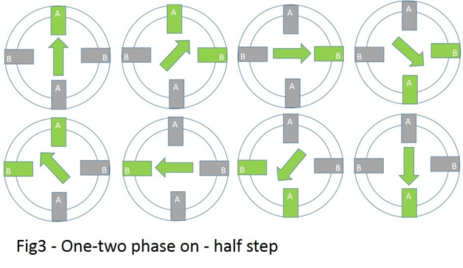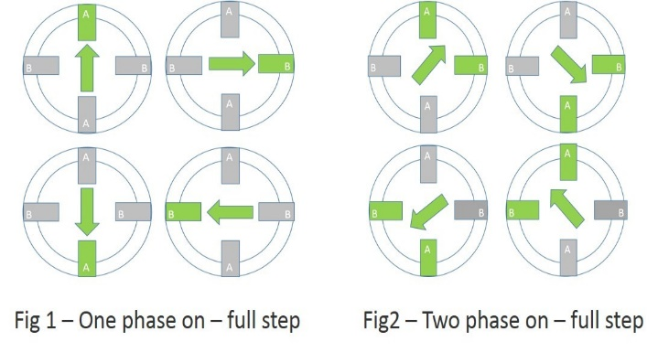Now that a function that controls both motor windings has been written, it can be used to drive a stepper motor. Inside of the stepper motor there are two windings that determine the orientation of the shaft. By turning on either one or two phases at a time, rotating the motor in full steps is possible.

By combining the two different stepping patterns, it is possible to double the resolution of the motor. This requires the current being applied to the windings to be varied based on whether or not one or two windings is on. This idea can be taken further by varying the current going through each winding proportionally to the desired angle between each step. This is called microstepping.

The PWM applied to the enable pins can be used to vary the current in the windings enough to control the angle of the motor shaft.

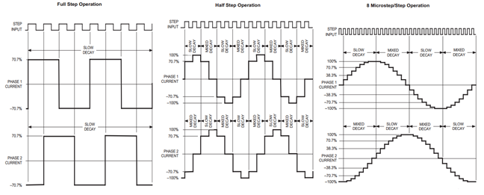

## Implementation of Task 3: PCB Layout

1. Conclusion.

By the end of the project, conclude the project and your learning experience.

Appendix

You can put reference info here, including: i) specs of components used in the system, ii) source code (must be here but not in the body text), iii) CAD figures, etc.

1. Component Specs
2. Specs of Arduino Due

...

1. Specs of Raspberry Pi

…

1. Source Code.
2. PWM Test Code

/*

* Senior Design.c

* PMW Test Code

*

* Created: 11/18/2018 1:29:49 PM

* Author: Derickson

*/

// ------- Preamble -------- //

#include <avr/io.h>

#include <util/delay.h>

#include <avr/interrupt.h>

#define ENA 128;

#define ENB 128;

// ---- L298 ENABLE Set Up --- //

int main(void){

DDRB |= 0b00000110;

TCCR1A = 0b11110001; //Configure timer 1 for fast PWM

TCCR1B = 0b00000010;

TCCR1C = 0b00000000;

OCR1A = ENA;

OCR1B = ENB;

while(1){}

return(0);

}

1. Single DC Motor Control Code

/*

* Senior Design.c

* Single Motor Test Code

*

* Created: 11/18/2018 1:29:49 PM

* Author : Derickson

*/

// ------- Preamble -------- //

#define *F_CPU* 8000000UL

#include <avr/io.h>

#include <util/delay.h>

#include <avr/interrupt.h>

#define ENA 128;

#define ENB 128;

// -------- Functions -------- //

static inline void motorInit(){

// ---- L298 INPUT Set Up ---- //

DDRB |= 0b00111001; // Set PB0,PB3,PB4,PB5 as output

// ---- L298 ENABLE Set Up --- //

DDRB |= 0b00000110; //Set pins PB1 and PB2 as OUTPUT

TCCR1A = 0b11110001; //Configure timer 1 for fast PWM

TCCR1B = 0b00000010;

TCCR1C = 0b00000000;

OCR1A = 0;

OCR1B = 0;

}

static inline void setBridgeState(*uint8_t* INPUT1,*uint8_t* INPUT2, *uint8_t* INPUT3, *uint8_t* INPUT4,*uint8_t* ENABLEA, *uint8_t* ENABLEB){

if(INPUT1){ PORTB |= (1 << PINB0); }

else{ PORTB &= ~(1 << PINB0); }

if(INPUT2){ PORTB |= (1 << PINB3); }

else{ PORTB &= ~(1 << PINB3); }

if(INPUT3){ PORTB |= (1 << PINB4); }

else{ PORTB &= ~(1 << PINB4); }

if(INPUT4){ PORTB |= (1 << PINB5); }

else{ PORTB &= ~(1 << PINB5); }

OCR1A = ENABLEA;

OCR1B = ENABLEB;

}

int main(void){

motorInit();

while(1){

setBridgeState(1,1,0,0,64,255);

*_delay_ms*(1000);

setBridgeState(1,0,0,0,64,255);

*_delay_ms*(2500);

setBridgeState(1,1,0,0,64,255);

*_delay_ms*(1000);

setBridgeState(0,1,0,0,64,255);

*_delay_ms*(2500);

}

return(0);

}

1. Stepper Motor Test Code

/*

* Senior Design.c

* Stepper Motor Test Code

*

* Created: 11/18/2018 1:29:49 PM

* Author : Derickson

*/

// ------- Preamble -------- //

#define *F_CPU* 8000000UL

#include <avr/io.h>

#include <util/delay.h>

#include <avr/interrupt.h>

#define ENA 128;

#define ENB 128;

// -------- Functions -------- //

static inline void motorInit(){

// ---- L298 INPUT Set Up ---- //

DDRB |= 0b00111001; // Set PB0,PB3,PB4,PB5 as output

// ---- L298 ENABLE Set Up --- //

DDRB |= 0b00000110; //Set pins PB1 and PB2 as OUTPUT

TCCR1A = 0b11110001; //Configure timer 1 for fast PWM

TCCR1B = 0b00000010;

TCCR1C = 0b00000000;

OCR1A = 0;

OCR1B = 0;

}

static inline void setBridgeState(*uint8_t* INPUT1,*uint8_t* INPUT2, *uint8_t* INPUT3, *uint8_t* INPUT4,*uint8_t* ENABLEA, *uint8_t* ENABLEB){

if(INPUT1){ PORTB |= (1 << PINB0); }

else{ PORTB &= ~(1 << PINB0); }

if(INPUT2){ PORTB |= (1 << PINB3); }

else{ PORTB &= ~(1 << PINB3); }

if(INPUT3){ PORTB |= (1 << PINB4); }

else{ PORTB &= ~(1 << PINB4); }

if(INPUT4){ PORTB |= (1 << PINB5); }

else{ PORTB &= ~(1 << PINB5); }

OCR1A = ENABLEA;

OCR1B = ENABLEB;

}

int main(void){

motorInit();

while(1){

for(int i = 0; i < 25 ; i++){

setBridgeState(1,0,1,0,32,32);

*_delay_ms*(25);

setBridgeState(0,1,1,0,32,32);

*_delay_ms*(25);

setBridgeState(0,1,0,1,32,32);

*_delay_ms*(25);

setBridgeState(1,0,0,1,32,32);

*_delay_ms*(25);

}

for(int i = 0; i < 25 ; i++){

setBridgeState(0,1,0,1,32,32);

*_delay_ms*(25);

setBridgeState(0,1,1,0,32,32);

*_delay_ms*(25);

setBridgeState(1,0,1,0,32,32);

*_delay_ms*(25);

setBridgeState(1,0,0,1,32,32);

*_delay_ms*(25);

}

}

return(0);

}

REFERENCES

[1] D. Vantrease, R. Schreiber, M. Monchiero, M. McLaren, N. P. Jouppi, M. Fiorentino*, et al.*, "Corona: System Implications of Emerging Nanophotonic Technology," in *Computer Architecture, 2008. ISCA '08. 35th International Symposium on*, 2008, pp. 153-164.

[2] X. Zhang and A. Louri, "A multilayer nanophotonic interconnection network for on-chip many-core communications," in *Design Automation Conference (DAC), 2010 47th ACM/IEEE*, 2010, pp. 156-161.

[3] C. Batten, A. Joshi, J. Orcutt, A. Khilo, B. Moss, C. Holzwarth*, et al.*, "Building manycore processor-to-DRAM networks with monolithic silicon photonics," in *High Performance Interconnects, 2008. HOTI '08. 16th IEEE Symposium on*, 2008, pp. 21-30.

[4] Y. Pan, P. Kumar, J. Kim, G. Memik, Y. Zhang, and A. Choudhary, "Firefly: illuminating future network-on-chip with nanophotonics," in *IEEE/ACM Intl. Symp. on Computer Architecture (ISCA)*, 2009, pp. 429-440.

[5] N. Kirman, M. Kirman, R. K. Dokania, J. F. Martinez, A. B. Apsel, M. A. Watkins*, et al.*, "Leveraging Optical Technology in Future Bus-based Chip Multiprocessors," in *Microarchitecture, 2006. MICRO-39. 39th Annual IEEE/ACM International Symposium on*, 2006, pp. 492-503.

[6] J. M. Cianchetti, C. J. Kerekes, and H. D. Albonesi, "Phastlane: a rapid transit optical routing network," in *Proceeding of: 36th International Symposium on Computer Architecture (ISCA)*, 2009, pp. 441-450.

[7] A. Shacham, K. Bergman, and L. P. Carloni, "Photonic Networks-on-Chip for Future Generations of Chip Multiprocessors," *Computers, IEEE Transactions on,* vol. 57, pp. 1246-1260, 2008.

[8] A. Shacham, K. Bergman, and L. P. Carloni, "On the Design of a Photonic Network-on-Chip," in *First International Symposium on Networks-on-Chip, 2007. NOCS 2007*, 2007, pp. 53-64.

[9] M. Kwai Hung, Y. Yaoyao, W. Xiaowen, Z. Wei, L. Weichen, and X. Jiang, "A Hierarchical Hybrid Optical-Electronic Network-on-Chip," in *VLSI (ISVLSI), 2010 IEEE Computer Society Annual Symposium on*, 2010, pp. 327-332.

[10] D. Ding and D. Z. Pan, "OIL: a nano-photonics optical interconnect library for a new photonic networks-on-chip architecture," presented at the Proceedings of the 11th international workshop on System level interconnect prediction, San Francisco, CA, USA, 2009.

[11] A. Joshi, C. Batten, K. Yong-Jin, S. Beamer, I. Shamim, K. Asanovic*, et al.*, "Silicon-photonic clos networks for global on-chip communication," in *Networks-on-Chip, 2009. NoCS 2009. 3rd ACM/IEEE International Symposium on*, 2009, pp. 124-133.

[12] D. Vantrease, R. Schreiber, M. Monchiero, M. McLaren, N. P. Jouppi, M. Fiorentino*, et al.*, "Corona: system implications of emerging nanophotonic technology," in *Proc. 35th IEEE/ACM Int'l Symp. Computer Architecture (ISCA)*, 2008, pp. 153-164.

[13] L. Zhang, E. Regentova, and X. Tan, "A 2D-Torus Based Packet Switching Optical Network-on-Chip Architecture," presented at the *IEEE International Symposium on Photonics and Optoelectronics* (SOPO 2011), Wuhan, China, 2011.

[14] L. Zhang, E. E. Regentova, and X. Tan, "Packet switching optical network-on-chip architectures," *Comput. Electr. Eng.,* vol. 39, pp. 697-714, 2013.

[15] G. Huaxi, X. Jiang, and W. Zheng, "A novel optical mesh network-on-chip for gigascale systems-on-chip," in *Circuits and Systems, 2008. APCCAS 2008. IEEE Asia Pacific Conference on*, 2008, pp. 1728-1731.

[16] G. Huaxi, X. Jiang, and Z. Wei, "A low-power fat tree-based optical Network-On-Chip for multiprocessor system-on-chip," in *Design, Automation & Test in Europe Conference & Exhibition, 2009. DATE '09.*, 2009, pp. 3-8.

[17] Y. Yaoyao, X. Jiang, H. Baihan, W. Xiaowen, Z. Wei, W. Xuan*, et al.*, "3-D Mesh-Based Optical Network-on-Chip for Multiprocessor System-on-Chip," *Computer-Aided Design of Integrated Circuits and Systems, IEEE Transactions on,* vol. 32, pp. 584-596, 2013.

[18] A. Shacham, K. Bergman, and L. P. Carloni, "Photonic networks-on-chip for future generations of chip multiprocessors," *IEEE Trans. Computers,* vol. 57, pp. 1246-1260, 2008.

[19] A. W. Poon, F. X. Xu, and X. Luo, "Cascaded active silicon microresonator array cross-connect circuits for WDM networks-on-chip," in *Proc. SPIE*, 2008, p. 689812.

[20] M. Lipson, "Compact Electro-Optic Modulators on a Silicon Chip," *IEEE Journal of Selected Topics in Quantum Electronics,* vol. 12, pp. 1520-1526, 2006.

[21] M. Lipson, "Guiding, modulating, and emitting light on Silicon-challenges and opportunities," *Lightwave Technology, Journal of,* vol. 23, pp. 4222-4238, 2005.

[22] T. Xianfang, Y. Mei, Z. Lei, J. Yingtao, and Y. Jianyi, "Wavelength-routed optical networks-on-chip built with comb switches," in *Photonics Conference (IPC), 2013 IEEE*, 2013, pp. 46-47.